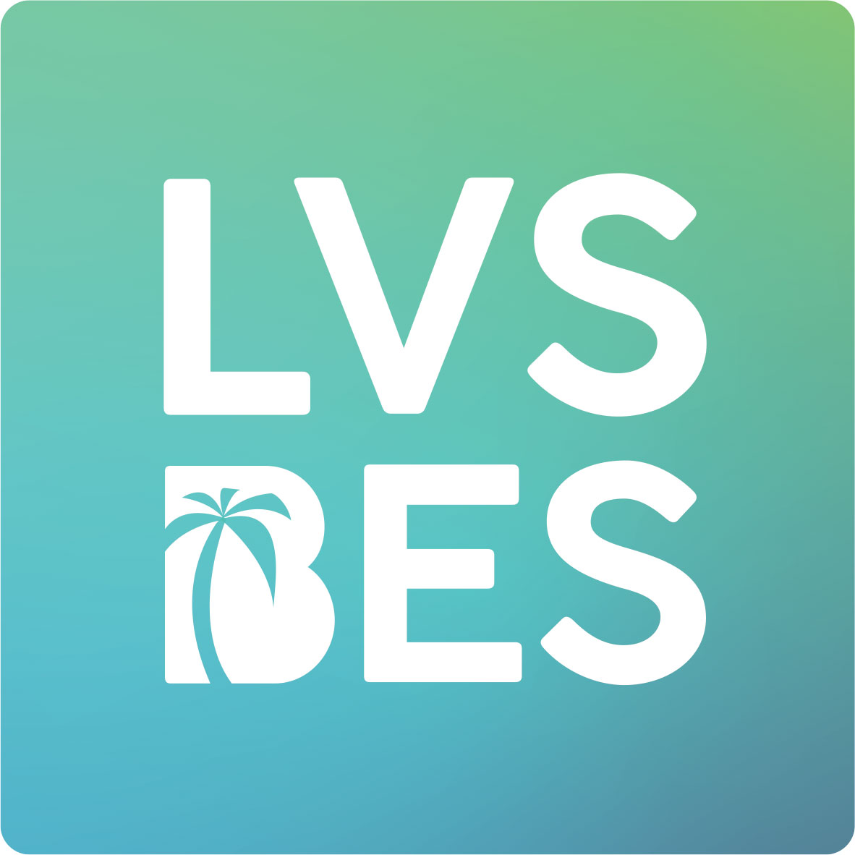
Dear parents/guardians,

From [xxx - xxx] your child will be taking tests for LVS BES.
What does LVS BES mean?
An LVS, leerlingvolgsysteem in Dutch or student monitoring system, gives teachers insight into the development of their students and allows them to cater to their needs. The LVS BES system contains tests for English and Dutch as a foreign language (NVT), and Basic Math which have been developed specifically for the students of Bonaire, Statia, and Saba (the BES-islands).
DOMAIN | COMPONENT
English | Reading
 | Listening
 | Writing
 | Speaking
NVT | Reading
 | Listening
 | Writing
 | Speaking
Basic Math
The tests can be administered twice a year, at a time decided by school.
Where can I find more information?
Please do not hesitate to contact your child’s teacher if you have any questions about LVS BES. You can find more information, including sample tests, on this website: https://www.bureau-ice.nl/caribisch-onderwijs/lvs-bes-english/.

